Git and GitHub

Assignment 0

1. Create a directory 'project_dir' & cd to 'project_dir.

2. Initialize git version database. (git init)

3. Create a new file index.html.)

4. Check the git status. You should find index.html as untracked file.

5. Stage the index.html file.

6. Commit index.html

7. Make few changes in index.html & create a new file info.txt file.

8. Check git status. You should find Index.html & info.txt as untracked files.

9. Configure GIT to ignore all txt files.

10. Again check the git status. You should find only index.html as untracked file.

11. State & commit index.html

12. Log all your comments so far.

13. Make some changes in index.html.

14. Revert the change made in the previous step using git command.

15. Again change index.html. 16. Stage index.html

17. Revert back the last stage.

18. Rename 'add command to 'my-add".

19. Using my add command Stage index.html

commit the changes.

20. Revert the last commit.

Assignment 1

21. First take a backup of your assignments & projects. This is required because due to Incorrect GIT operation you may lose your files.

22. Create an empty directory 'Assignments' & cd to 'Assignments.

23. Create a file README.txt inside 'Assignments & write few lines about the contents of

Assignments' folder.

24. Commit README.txt file.

25. Now create a new branch ‘html-assignment”.

26. Switch to "html-assignments' branch.

27. Copy all HTML assignments Inside Assignments' folder.

28. Commit HTML assignments into "html-assignments" branch.

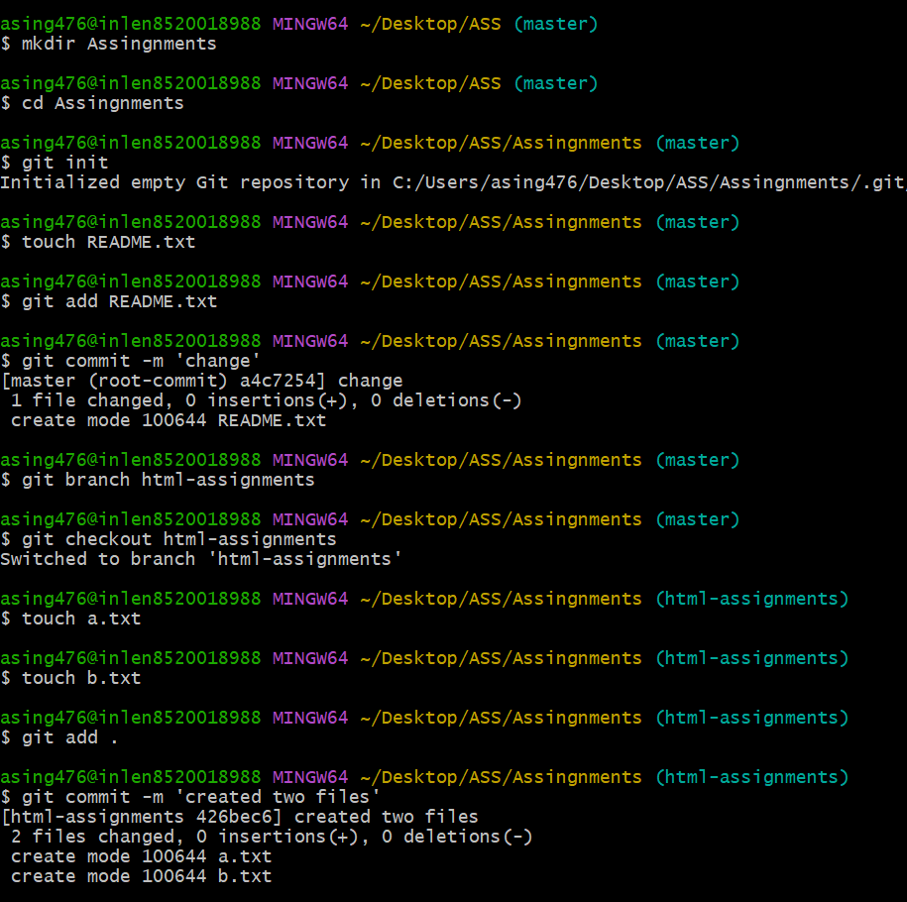

29. Make minor changes into few files belonging to 'html-assignments' branch.

30. Commit those changed files.

31. Switch to master branch.

32. Make minor changes into README.txt file & commit those changes into master.

33. Again switch to 'html-assignments' branch.

34. Make minor changes into few files belonging to 'html-assignments' branch.

35. Commit those changes.

36. Switch to master.

37. Merge "html-assignments' branch into master. Confirm all html assignments are shown

in master.

38. Finally delete the 'html-assignments' branch.

Assignment 2

1. Create a new branch 'css-assignments".

2. Switch to 'css-assignments' branch.

3. Copy all CSS assignments inside 'Assignments' folder.

4. Commit CSS assignments into 'css-assignments' branch.

5. Make minor changes into README.txt file on line 1 belonging to 'css-assignments branch.

9. Again switch to 'css-assignments' branch.

10. Make minor changes into few files belonging to 'css-assignments' branch.

11. Commit those changes.

12. Switch to master.

13. Merge "css-assignments branch into master. Confirm all css assignments are shown in master.

14. Finally delete the 'css-assignments' branch.

Assignment 3

1. Create a new branch 'js-assignments

2. Switch to 'js-assignments' branch.

3. Copy all JavaScript assignments inside 'Assignments' folder.

4. Commit JavaScript assignments into "js-assignments' branch.

5. Make minor changes into README.txt file on line 1 belonging to is assignments' branch.

6. Commit those changed files.

7. Switch to master branch.

8 Make minor changes into README.txt file on line 1 & commit those changes into master.

9. Again switch to ‘js-assignments' branch.

10. Make minor changes into few files belonging to js-assignments' branch.

11. Commit those changes.

12. Switch to master.

13. Merges-assignments branch into master. Confirm all JavaScript assignments are shown in master.

14. Finally delete the s-assignments' branch

39. Create a GitHub account if you do not have already

40. Login on into GitHub account 41 Create new public repository freshersbatch-oct16"

42. Commit & push any sample file to this repository under Assignments directory

Assignment 4

1. One developer from project team will create eclipse projects 'Sample Proj' & add sample

source code files. Then commit all files through eclipse GIT plugin.

2. Collaborate other team members with your GitHub account so that they can also modify the committed files.

3. Other developers from same team will checkout all files from remote repository. This might get conflicts since certain files fail to merge. In such case, merge it manually.

4. Commit & push the 'SampleProj' project.

